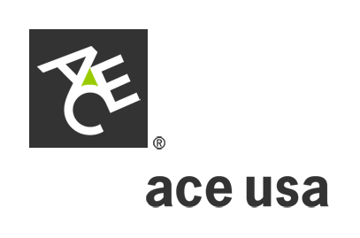
3 Easy Steps
1) Fill out application online by tabbing through the fields.
2) Email:
- Save application to your hard drive (File > Save As >)
- File Menu > Send to >Mail Recipient (as attachment)
- To: AdvantagePartners@acegroup.com
- OR, Fax:
- Save application to your hard drive (File > Save As >)
- Fax To: Advantage Partners @ 302-476-6456
Any questions please call: 1-800-204-0518
International Advantage®
Casualty Application

Customer Broker/Agent
Address Address

Contact Contact
E-mail E-mail
Phone Phone
quote needed By Fax
Intended Inception
SS# or Dunn & Bradstreet#

Individual Corporation Subchapter “S” Corporation Not for Profit
Partnership Joint Venture Limited Corporation Years in Business:
General Information
Description of Foreign Operations:

List Countries where customer will work/travel, or sell products:

Loss History Past 5 Years:
Current international insurance carrier: Premium: $
Does the customer have any foreign subsidiaries? Yes No If yes, please attach a list.

General Liability: (Choose One)
Foreign Sales: Contract Cost: No. of leased or owned Premises:
Domestic GL Rate/Carrier: Number of foreign trips/purpose:
Administration: (sales/clerical) Labor: (physical/manual labor)
Standard Limit is $1,000,000.
Any Excess Limits for: Occurrence Products Personal/Advertising Injury
1901 08-2005
Contingent Auto:
Number of Foreign Owned Autos:
Standard Limit is $1,000,000. Any Excess Limits:

Employers Responsibility – Indicate trip and/or payroll exposure in charts below:
Number of Trips is calculated as number of employees X trips. (Example: 8 employees taking 3 trips each = 24 trips).
Number of Foreign Trips and Duration:
Trip Purpose Number Duration (Avg. Days)
Administrative (sales, clerical)
Labor (physical/manual labor)

Number and Payroll of Employees Abroad:
Trip Purpose Number U.S. Nationals Number Third Country Nationals Number Local Nationals
Administrative $ $ $
(sales, clerical)
Labor (physical/ $ $ $
manual labor)

Employers Liability: Standard Limit is $1,000,000. Any Excess Limits:

Employee Medical And AD&D: Medical $10,000 $25,000
AD&D $100,000 $250,000
Number of Employees: Number of Trips: Average Length of Stay:
Separate Applications required for:
Kidnap & Extortion Property Defense Base Act

Signed Title Date

1901 08-2005

